**IBM Cloud Pak for Business Automation**

**Demos and Labs**

IBM Process Mining

Using BPMN Process Diagrams from IBM Blueworks Live in IBM Process Mining

V 4.0

Paul Pacholski

[pacholsk@ca.ibm.com](mailto:pacholsk@ca.ibm.com)

Patrick Megard

[patrick.megard@fr.ibm.com](mailto:patrick.megard@fr.ibm.com)

Latest version: <https://ibm.box.com/v/ProcessMiningLab3>

NOTICES

This information was developed for products and services offered in the USA.

IBM may not offer the products, services, or features discussed in this document in other countries. Consult your local IBM representative for information on the products and services currently available in your area. Any reference to an IBM product, program, or service is not intended to state or imply that only that IBM product, program, or service may be used. Any functionally equivalent product, program, or service that does not infringe any IBM intellectual property right may be used instead. However, it is the user's responsibility to evaluate and verify the operation of any non-IBM product, program, or service.

IBM may have patents or pending patent applications covering subject matter described in this document. The furnishing of this document does not grant you any license to these patents. You can send license inquiries, in writing, to:

IBM Director of Licensing

IBM Corporation

North Castle Drive, MD-NC119

Armonk, NY 10504-1785

United States of America

The following paragraph does not apply to the United Kingdom or any other country where such provisions are inconsistent with local law: INTERNATIONAL BUSINESS MACHINES CORPORATION PROVIDES THIS PUBLICATION "AS IS" WITHOUT WARRANTY OF ANY KIND, EITHER EXPRESS OR IMPLIED, INCLUDING, BUT NOT LIMITED TO, THE IMPLIED WARRANTIES OF NON-INFRINGEMENT, MERCHANTABILITY OR FITNESS FOR A PARTICULAR PURPOSE. Some states do not allow disclaimer of express or implied warranties in certain transactions, therefore, this statement may not apply to you.

This information could include technical inaccuracies or typographical errors. Changes are periodically made to the information herein; these changes will be incorporated in new editions of the publication. IBM may make improvements and/or changes in the product(s) and/or the program(s) described in this publication at any time without notice.

Any references in this information to non-IBM websites are provided for convenience only and do not in any manner serve as an endorsement of those websites. The materials at those websites are not part of the materials for this IBM product and use of those websites is at your own risk.

IBM may use or distribute any of the information you supply in any way it believes appropriate without incurring any obligation to you.

Information concerning non-IBM products was obtained from the suppliers of those products, their published announcements or other publicly available sources. IBM has not tested those products and cannot confirm the accuracy of performance, compatibility or any other claims related to non-IBM products. Questions on the capabilities of non-IBM products should be addressed to the suppliers of those products.

This information contains examples of data and reports used in daily business operations. To illustrate them as completely as possible, the examples include the names of individuals, companies, brands, and products. All of these names are fictitious and any similarity to the names and addresses used by an actual business enterprise is entirely coincidental.

**TRADEMARKS**

IBM, the IBM logo, and ibm.com are trademarks or registered trademarks of International Business Machines Corp., registered in many jurisdictions worldwide. Other product and service names might be trademarks of IBM or other companies. A current list of IBM trademarks is available on the web at "Copyright and trademark information" at www.ibm.com/legal/copytrade.shtml.

Adobe, the Adobe logo, PostScript, and the PostScript logo are either registered trademarks or trademarks of Adobe Systems Incorporated in the United States, and/or other countries.

Cell Broadband Engine is a trademark of Sony Computer Entertainment, Inc. in the United States, other countries, or both and is used under license therefrom.

Intel, Intel logo, Intel Inside, Intel Inside logo, Intel Centrino, Intel Centrino logo, Celeron, Intel Xeon, Intel SpeedStep, Itanium, and Pentium are trademarks or registered trademarks of Intel Corporation or its subsidiaries in the United States and other countries.

IT Infrastructure Library is a Registered Trade Mark of AXELOS Limited.

ITIL is a Registered Trade Mark of AXELOS Limited.

Java and all Java-based trademarks and logos are trademarks or registered trademarks of Oracle and/or its affiliates.

Linear Tape-Open, LTO, the LTO Logo, Ultrium, and the Ultrium logo are trademarks of HP, IBM Corp. and Quantum in the U.S. and other countries.

Linux is a registered trademark of Linus Torvalds in the United States, other countries, or both.

Microsoft, Windows, Windows NT, and the Windows logo are trademarks of Microsoft Corporation in the United States, other countries, or both.

UNIX is a registered trademark of The Open Group in the United States and other countries.

© Copyright International Business Machines Corporation 2020.

This document may not be reproduced in whole or in part without the prior written permission of IBM.

US Government Users Restricted Rights - Use, duplication or disclosure restricted by GSA ADP Schedule Contract with IBM Corp.

**Table of Contents**

1 Introduction 4

1.1 IBM Process Mining 4

1.2 IBM Blueworks Live 4

1.3 Process Modeling and Process Mining Working Together 4

1.3.1 Business Scenario 5

1.4 How to Prepare IBM Blueworks Live Process? 6

1.4.1 Basic Requirements 6

1.4.2 Process Mining Simulation Parameters 6

1.4.3 Exporting Process from IBM Blueworks Live 7

2 Lab Setup 8

2.1 Import Lab Files 8

2.2 Open IBM Process Mining Application 8

3 Lab Instructions 10

3.1 Create BPMN Process 10

3.2 Initialize and Run Simulation 11

3.2.1 Create a Simulation 11

3.2.2 Initialize Simulation Parameters – Service Time 13

3.2.3 Initialize Simulation Parameters – Gateway 14

3.2.4 Run Simulation and Create a Project 14

3.3 Examine Generated Process Data 16

3.3.1 Activity cost 16

3.3.2 Frequency View 17

3.3.3 Duration View 18

3.3.4 Cost View 19

3.3.5 Variants 20

3.3.6 Social discovery capabilities 21

3.4 Create Additional Events Using New Simulation Scenarios 22

3.4.1 Create new Simulation Scenario 22

3.4.2 Change Simulation Scenario Parameters 22

3.4.3 Introduce Automation 23

3.4.4 Run the Simulation ad Import Simulation Data 24

3.4.5 Managing Event Data 25

3.5 Lab Summary 26

# Introduction

## IBM Process Mining

IBM Process Mining supports analyzing actual business processes based on event logs. During process mining, specialized data mining algorithms are applied to identify trends, patterns, and details in event logs recorded by an information system. Process mining aims to improve process efficiency and understanding of processes.

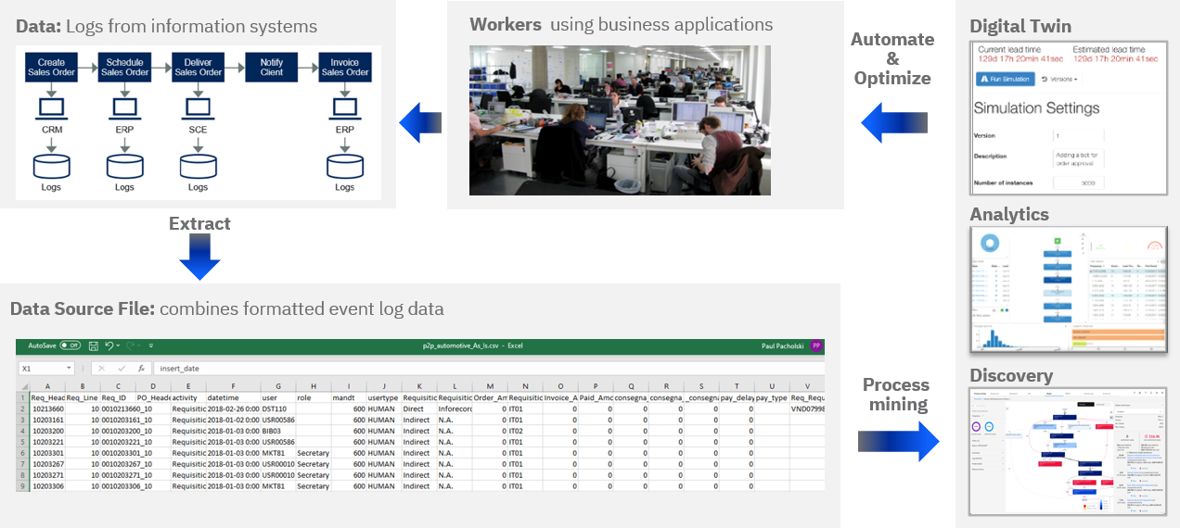

## IBM Blueworks Live

IBM Blueworks Live is a cloud-based software that provides a dedicated, collaborative environment to build and improve business processes through process mapping. It enables teams to work together through an intuitive and easily accessible web interface to document and analyze processes to help make them more efficient.

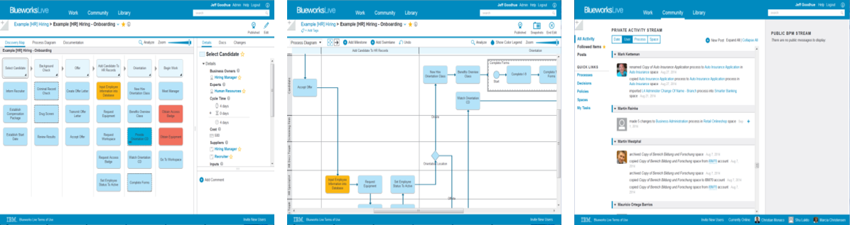

## Process Modeling and Process Mining Working Together

While IBM Blueworks Live supports all aspects of process modeling, it provides no simulation capabilities. On the other hand, IBM Process Mining provides simulation capabilities useful to establish ROI associated with automation initiatives, but it does not provide process modeling and discovery capabilities.

In this lab, you will learn how to leverage IBM Process Mining to simulate BPMN processes modeled in IBM Blueworks Live.

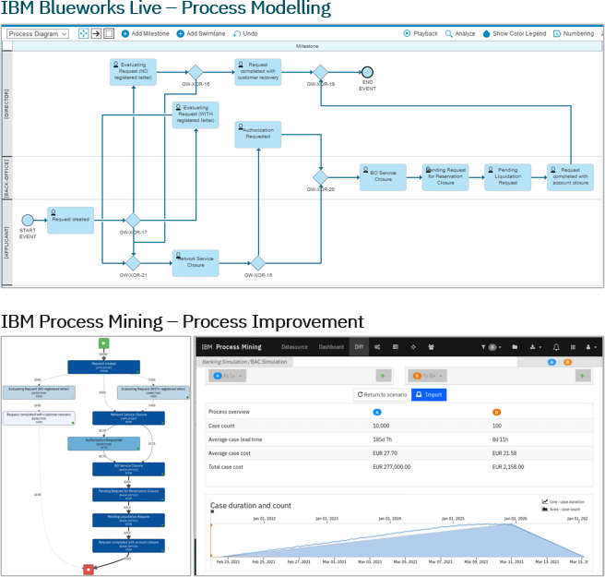

Typically, complete logs from all systems are required to engage in process mining activities. Extraction and preparation of such logs is a costly and time-consuming activity and is a significant entry barrier for organizations to benefit from process mining tools such as IBM Process Mining.

In this lab will learn how IBM Process Mining simulation can generate events. And how to use IBM Process Mining to generate event data required for most process mining tasks that do not require business data beyond the primary process data such as Activity Wait Times, Teams, Users, etc.

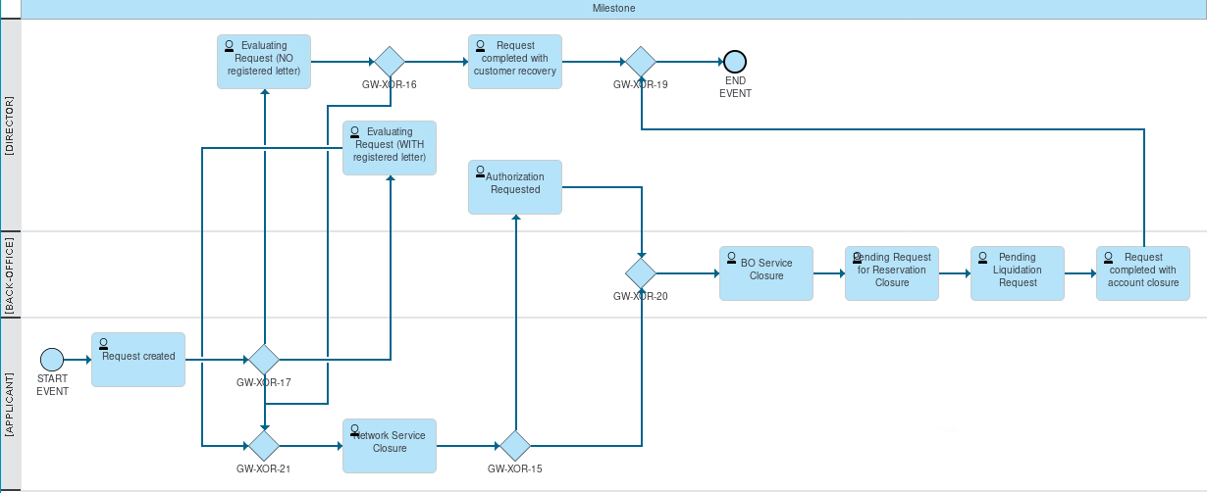

## How to Prepare IBM Blueworks Live Process?

You do not need to perform any labs steps in this section and its subsections.

The purpose of this section is to outline the technical requirements and steps needed to generate a well-behaved BPMN process diagram that works well with IBM Process Mining.

The Bank Account Opening process used in this lab was already created and exported, so you do not need to build it in IBM Blueworks Live. If you want to examine the process used in this lab, you can import it to IBM Blueworks Live using the *Banking Account Closure.zip* (see download instructions in **2.1 Import Lab Files** section)

### Basic Requirements

The process model must **not** include the following BPMN Modelling Elements

* Message Events

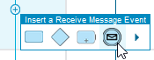

* Subprocesses

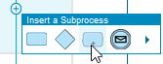

* Multiple links lead out an activity

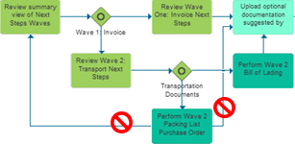

The following settings will be used by the simulation feature in IBM Process Mining.

### Process Mining Simulation Parameters

For each Activity in the process, three attributes can be set for use in IBM Process Mining simulations: (i) Work time, (ii) Wait time, (iii) Cost.

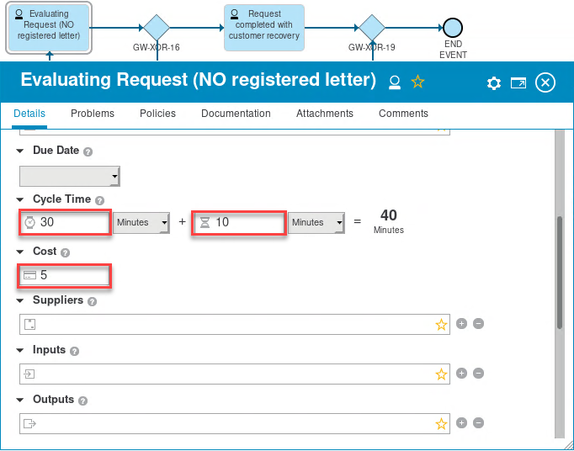

### Exporting Process from IBM Blueworks Live

1. Use standard BWL Process Export.

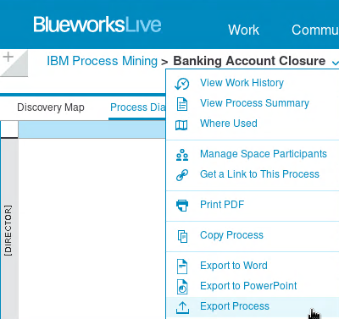

1. Select **BPMN 2.0**

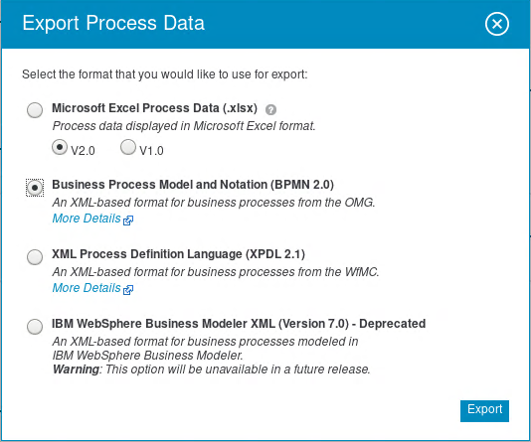

This will create a zip file.



Note you will not be able to import this zip file directly to IBM Process Mining. You will need to extract the BPMN file first.

1. To extract the BPMN file, open the exported zip file, navigate to the BPMN file and extract it from the zip file.

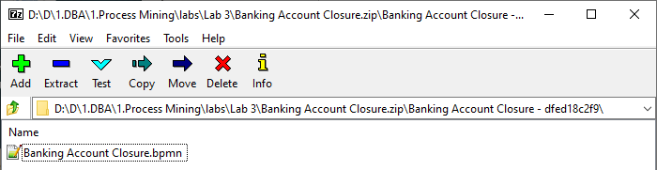

# Lab Setup

## Import Lab Files

1. Download the following files, you will use them in this lab:

|  |  |
| --- | --- |
| File | Link |
| Banking Account Closure.bpmn | <https://ibm.box.com/v/PM-LAB-3-BPMN> |
| Banking Account Closure.zip | <https://ibm.box.com/v/PM-LAB-3-BWL-IMPORT> |

## Open IBM Process Mining Application

If you are performing this lab as a part of an IBM event, access the document that lists the available systems and URLs along with login instructions. For this lab, you will need to access **IBM Automation Studio.**

1. Start your browser and use the **IBM Automation Studio** link
2. Click **Enterprise LDAP**

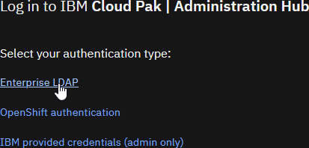

1. Enter your username and password, and then click **Log in**

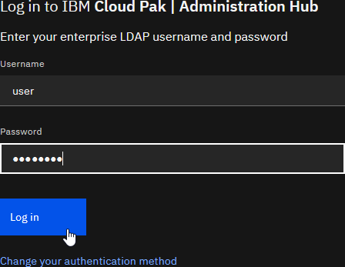

1. Click **Navigation Menu**

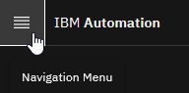

1. Select **Process mining**

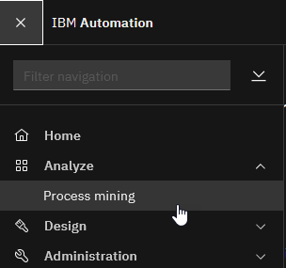

1. If you see the Welcome window, check **Don't show this message again** check box and click **Let's go!**

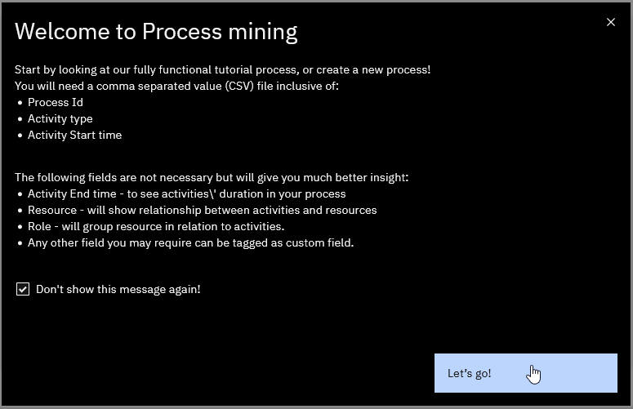

You should now see IBM Process Mining web UI

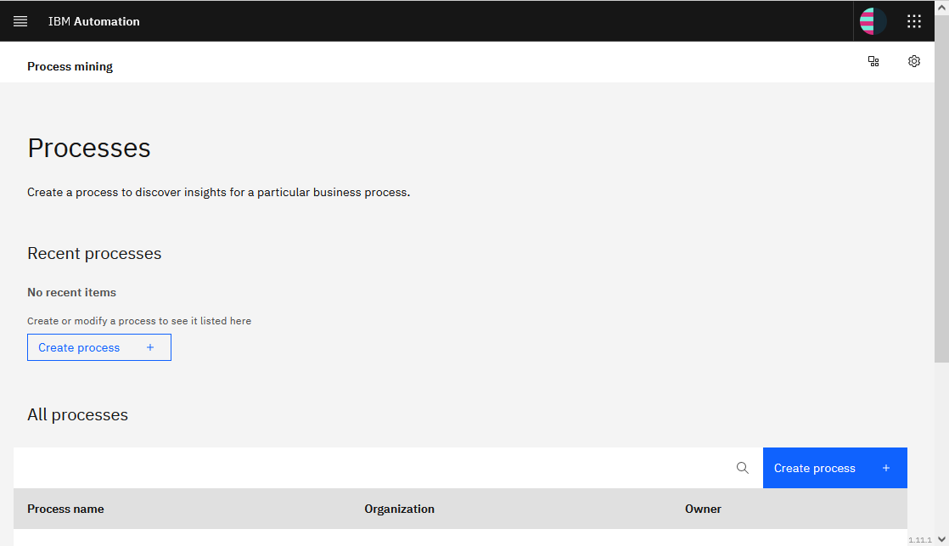

# Lab Instructions

## Create BPMN Process

You will now use the BPMN file extracted from the IBM Blueworks Live process export file to create the BPMN process in IBM Process Mining.

1. Click in **3-3 grid** and then select **BPA**

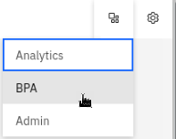

1. Select **+ Create New > Process**

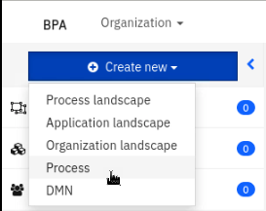

1. Enter the following and then click **Create**

*Add to* - select **New Process**

*Organization* - select **local**

*Name* - enter **BAC**

*Import from file (optional) -* select **Banking Account Closure.bpmn** file

Note: if you are using a shared environment, please use your user name prefix in the process name when creating a new process. For example, **UserXXX BAC**.

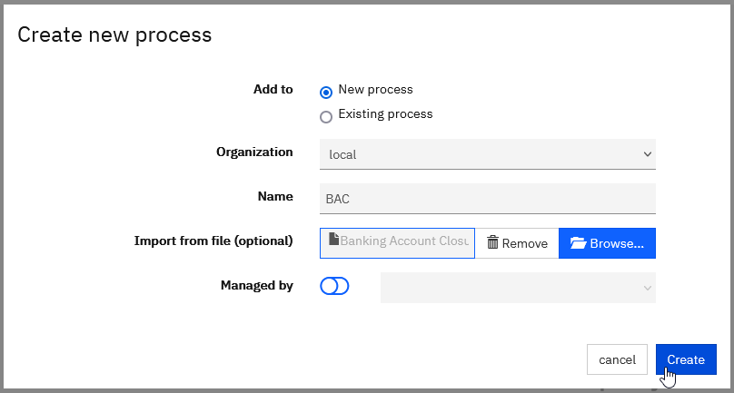

You should now see the BPMN diagram equivalent to the BWL process diagram

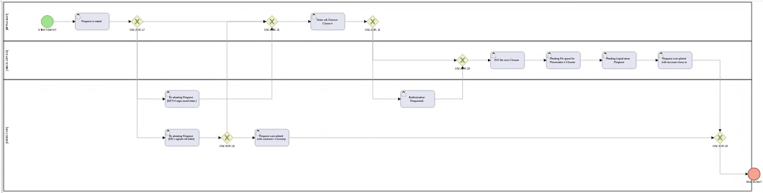

Figure 1. IBM Process Mining

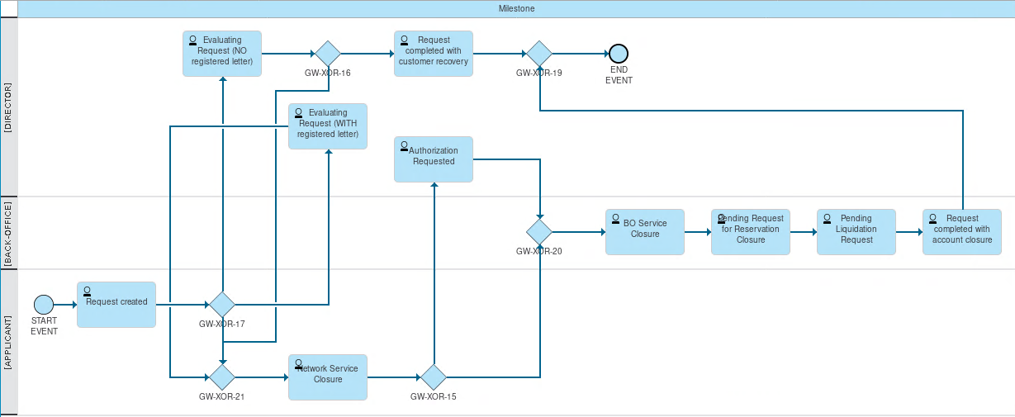

Figure 2. IBM Blueworks Live

## Initialize and Run Simulation

In this part of the lab, you will review and initialize missing simulation parameters. Then you will simulate to generate Process events used by IBM Process Mining to create a Project.

The Process Mining Project created from the simulated events can be used to gain business insights and discover automation opportunities to improve the process you modeled in IBM Blueworks Live.

### Create a Simulation

1. Click **Simulation** button

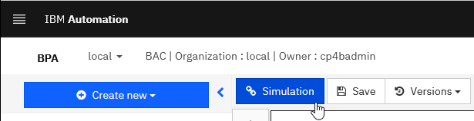

1. On Create new simulation scenario window for Simulation Title enter **BACSimulation** and then click **Confirm**

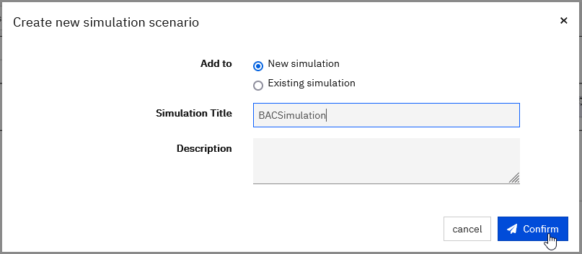

You should now see the new BACSimluation simulation

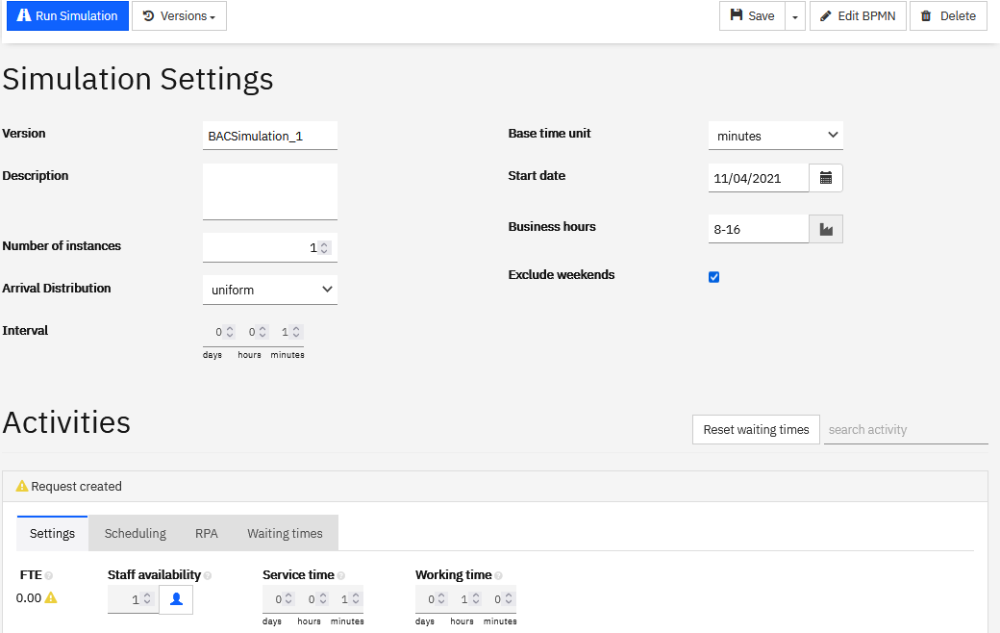

You will now be changing Activities and Gateway settings.

### Initialize Simulation Parameters – Service Time

#### Why do we need to change Service Time?

The BPMN import transformation maps the **Work Time (30)** to **Working time** **(30)** but does not use **Wait time (10).**

See thediagram below:

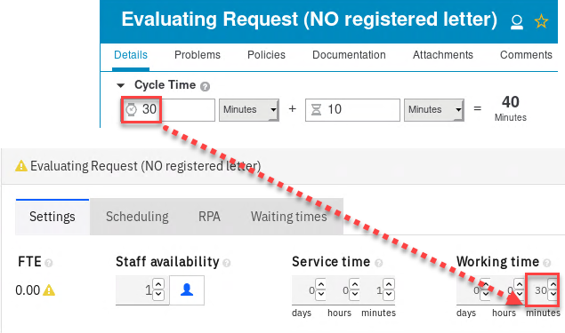

To make the simulation more accurate, you will need to set **Service time** (in IBM Process Mining) to the sum of **Work Time** and **Wait Time** (from IBM Blueworks Live) as shown below:

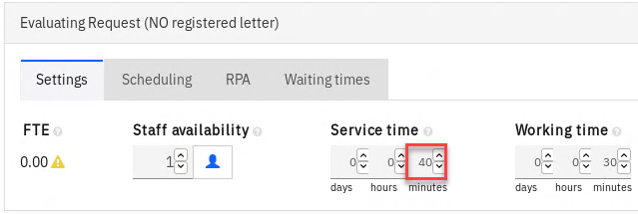

#### Change Service Time

Use the table below to set **Service time** for all activities:

|  |  |
| --- | --- |
| Activity | Service time |
| Request created | 1 hour 20 min |
| Evaluating Request (NO registered letter) | 40 min |
| Evaluating Request (WITH registered letter) | 47 min |
| Request completed with customer recovery | 15 min |
| Network Service Closure | 1 hour 33 min |
| Authorization Requested | 23 min |
| BO Service Closure | 52 min |
| Pending Request for Reservation Closure | 22 min |
| Pending Liquidation Request | 11 min |
| Request completed with account closure | 14 min |

For example, enter **1 hour 20** for **Request created**

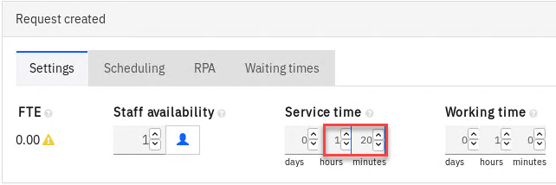

### Initialize Simulation Parameters – Gateway

Optionally you can also change the gateway flow distribution ratios.

1. For example, for the first Gateway, you can change the default from 50/50 to **40/60**

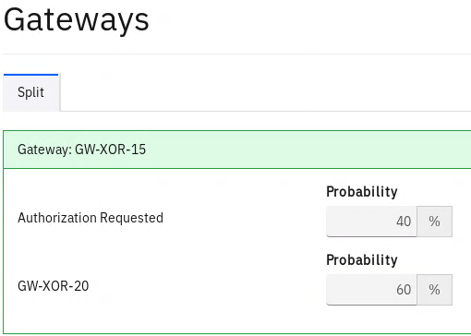

### Run Simulation and Create a Project

The Simulation Settings section contains nine parameters that you can adjust as required. In this lab, we will accept all the defaults except for **Number of instances** parameter.

1. For *Number of instances* enter **1000**

This will generate 1000 Cases (instances) and, for each instance, a variable number of Activity Events (enough events to complete a process instance).

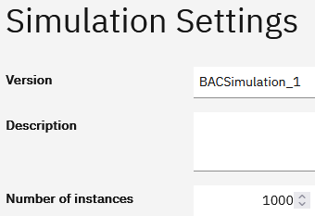

1. Click **Run Simulation**



Note, the Simulation Engine generated 1000 process instances, generated Activity events for each Process instance, and used the Execution and Wait Time settings we set for each Activity.

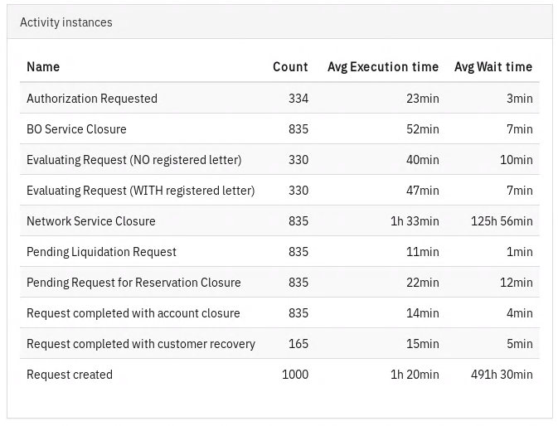

1. Click **Create Project**

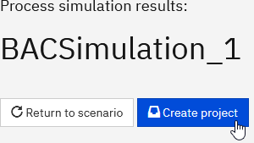

1. Click **Confirm**

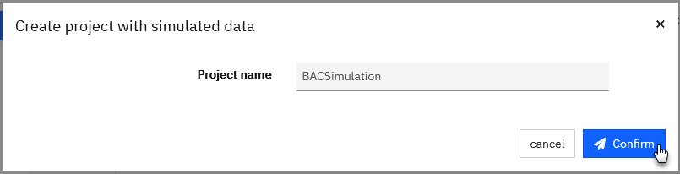

This will open BACSimulation Project in the IBM Process Mining tool in the Model View.

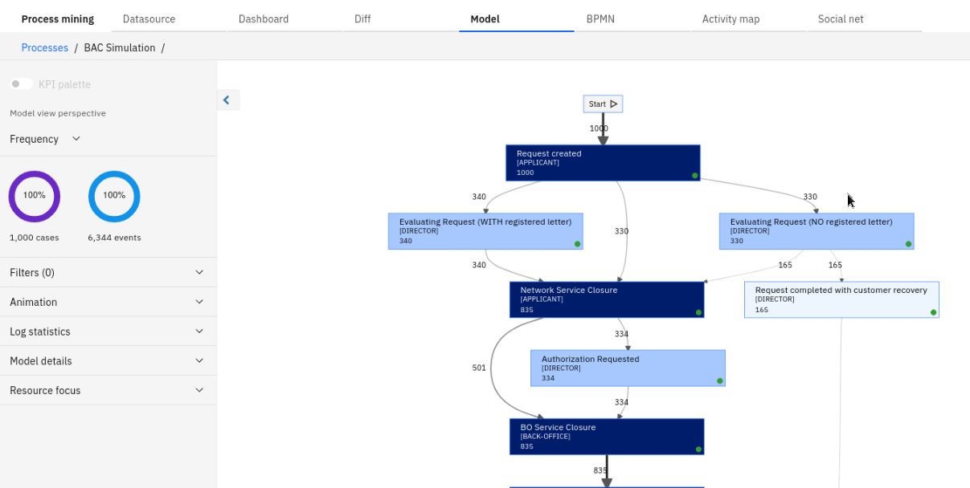

## Examine Generated Process Data

In this part of the lab, we will examine what data was generated by the simulation engine.

You will find enough data to conduct meaningful process mining activities!

### Activity cost

1. Click **Settings**

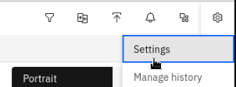

1. Click **Activity costs** tab

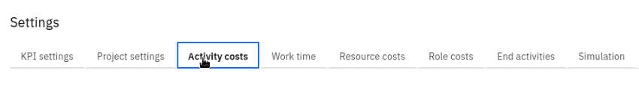

Note that the cost values came from the Activity Settings in IBM Blueworks Live

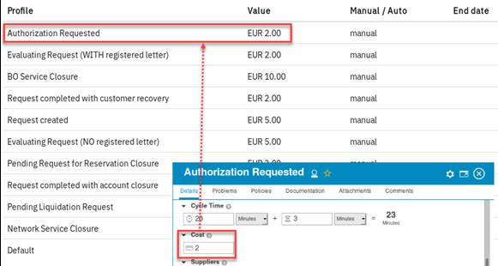

1. On Settings window click **Cancel**

### Frequency View

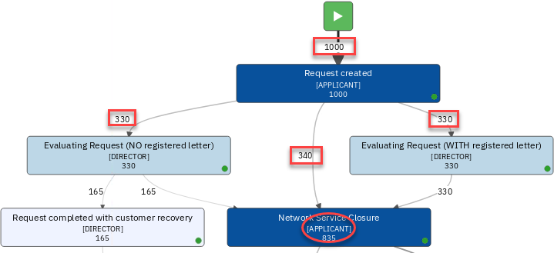

Note

* The event frequency is shown on the links. Recall that we set the summation count to 1000, and the first Gateway was set by default to be split evenly at 33%, 33%, 34%. Hence the even path distribution leading out of the first Activity: 330, 340, and 330.
* The Role (.i.e. [APPLICANT]) is shown.! It comes from the swim-lane definitions in IBM Blueworks Live.

### Duration View

1. Click **Average duration**

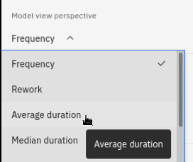

You should now see the Duration View similar to this. (Note, your color settings may be different from what is shown in the screenshot below)

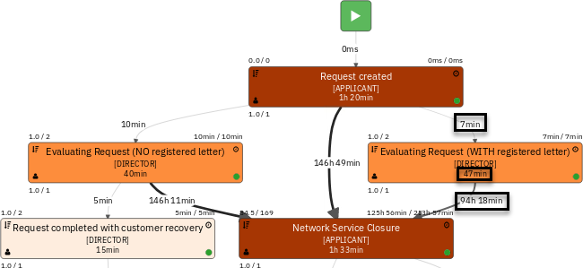

Note:

* Activity duration
* Wait times leading to activities
* Visual cues (arrow width and activity coloring) are based on the KPI settings in Project Settings. (Note, your KPI settings may be different from what is shown in the screenshot below)

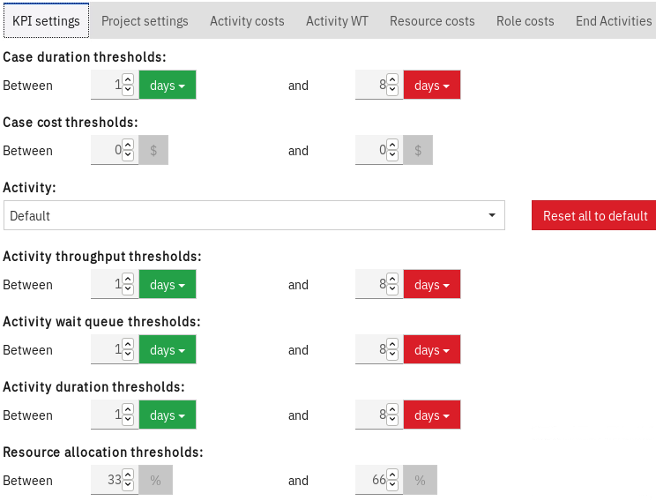

### Cost View

1. Click **Cost**

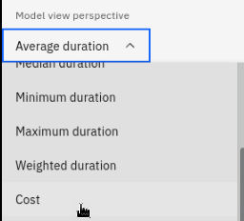

You should now see the Cost View. (Note, your color settings may be different from what is shown in the screenshot below)

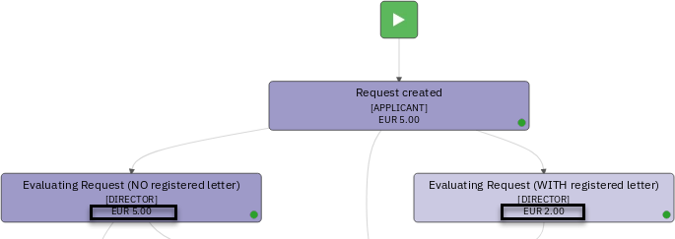

Notice that the role cost is not reflected.

1. Click **Settings**



1. Click **Role cost** tab and click **+**

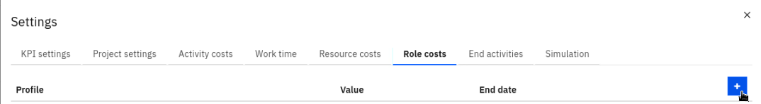

1. For Profile select **[DIRECTOR],** for Value select **20** and then click **Update** button

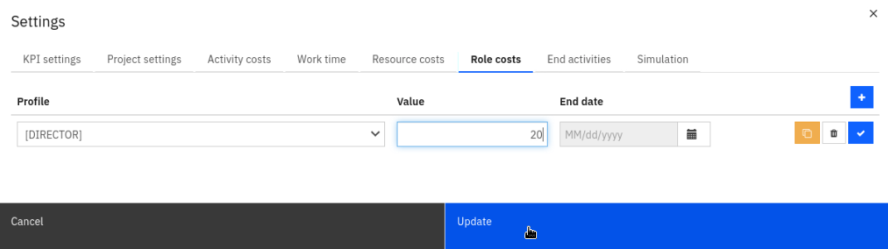

Note the changes of the [Director] role activities. (Note, your color settings may be different from what is shown in the screenshot below)

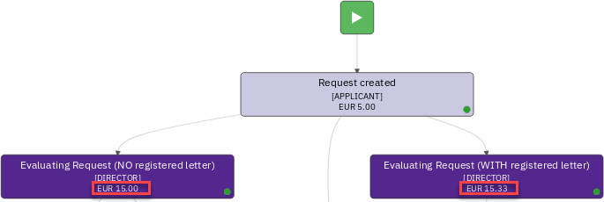

The cost is now more realistic, and the color has darkened to reflect cost values exceeding EUR 12.0.

### Variants

1. Click **TWISTED-ARROWS** button

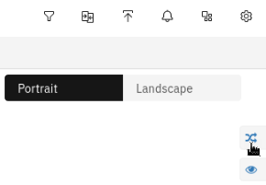

Notice that the simulation generated event data that resulted in distinct process path variants.

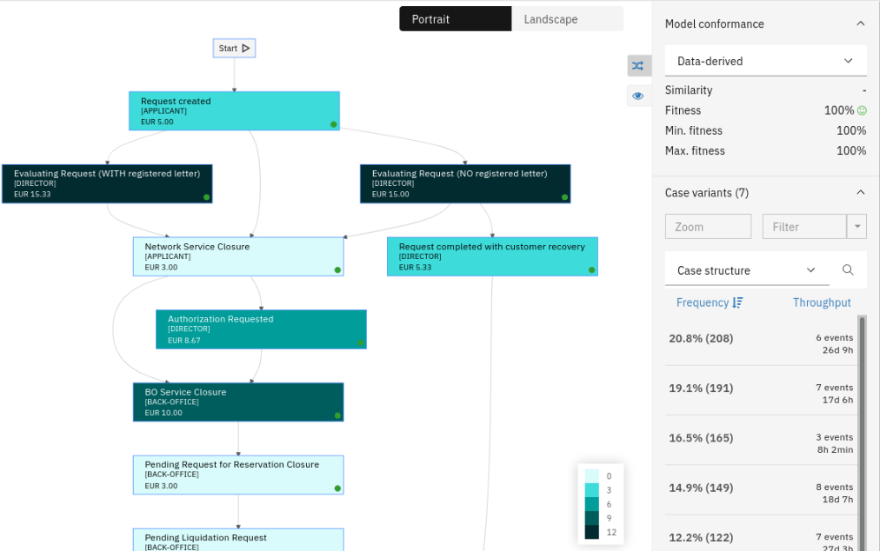

### Social discovery capabilities

1. Click **Activity map** button

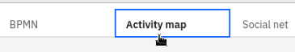

The simulation engine created 10 users and associated them with the Roles. Recall that the Roles originated from swim-lanes in IBM Blueworks Live

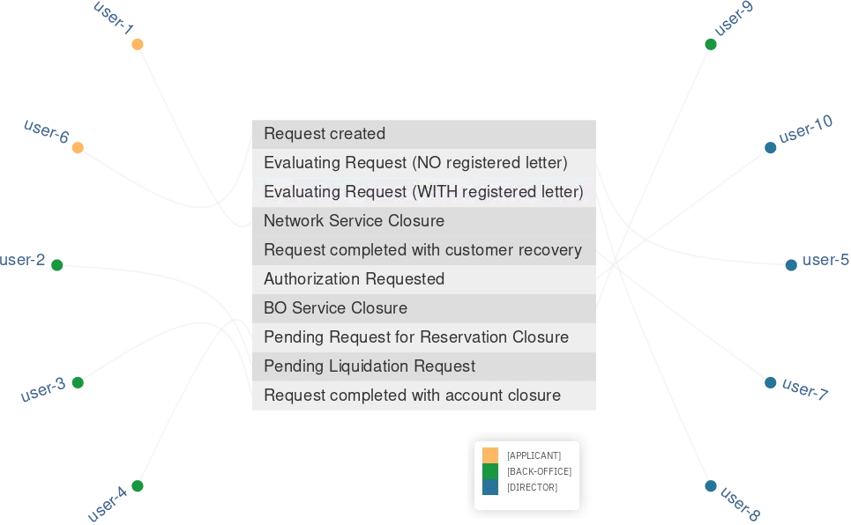 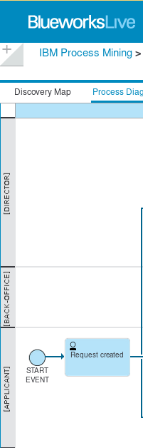

1. Click the **Social net** button



Note the user distribution in the social model.

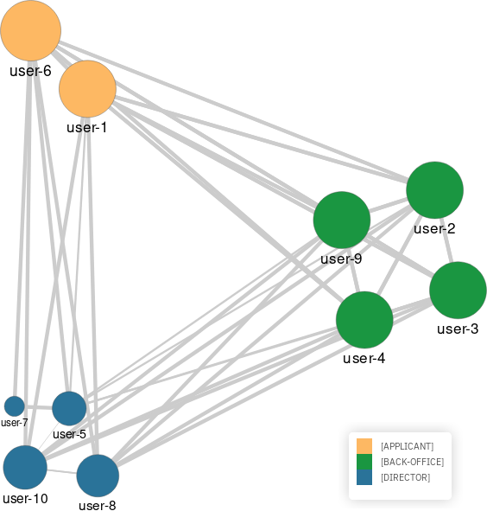

## Create Additional Events Using New Simulation Scenarios

In this part of the lab, you will learn how to add more data using different simulation settings.

### Create new Simulation Scenario

1. Click **BPMN** button



1. Click **Simulation** button



1. For Add to select **Exiting simulation**; for Simulation Title select **BAC Simulation**; for Version Name enter **2**; and then click **Confirm** button.
2. 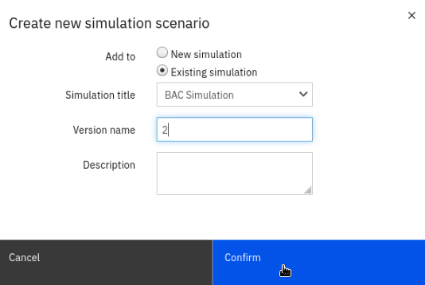

### Change Simulation Scenario Parameters

Let's change some simulation parameters.

1. Change Number of instances to **1500**



1. For all activities, change Staff availability from 1 to **10**

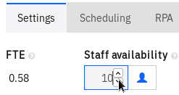

1. Change Gateway: GW-XOR-14 Probability to **20 and 80.**

Note that gateway names are generated randomly, so the names may differ from what you see in the screenshots below.

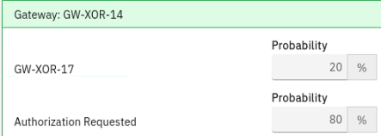

1. Change Gateway: GW-XOR-15 Probability to **50, 30 and 20**

Note that gateway names are generated randomly, so the names may differ from what you see in the screenshots below.

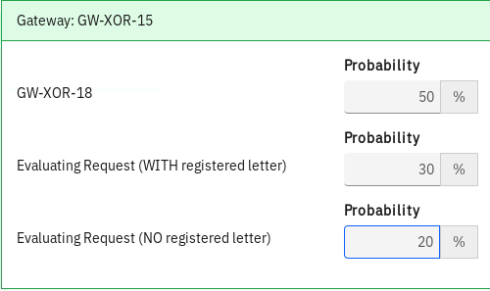

### Introduce Automation

One of the activities will be partially automated by RPA bots. We will reduce the number of people available and add RPA Bots.

1. For Network Service Closure, change the Staff Availability to **1**

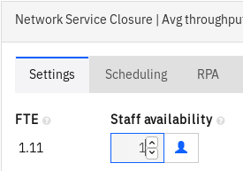

1. Click **RPA tab**

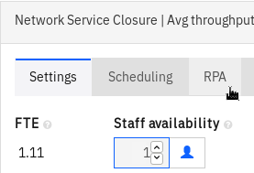

1. For Robotic quote, enter **90**, and for Number of robots, enter **22**

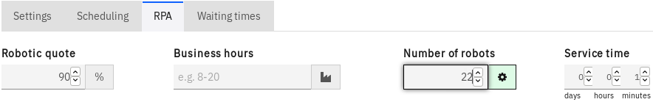

### Run the Simulation ad Import Simulation Data

We will now run the new simulation scenario to generate new events and conditionally import the new events to the main model.

1. Click **Run Simulation**

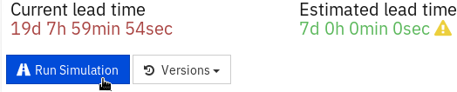

This action generated the comparison between the original (A) and new simulation scenario (B).

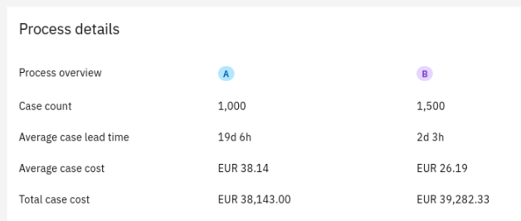

Note that the above simulation result screenshot may differ slightly. Remember, the simulation uses uniform distribution when generating events!

We now have two choices:

1. If we are not satisfied with the generated data, we can click the *Return to scenario* button and make desired simulation parameter changes.
2. If we are satisfied with the results, we can click the *Import* button to add the generated events to our main model.

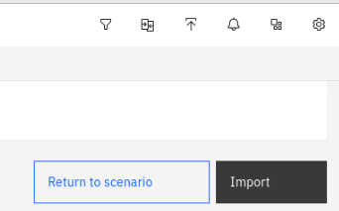

1. Click **Import**



Note that now see 1500 more cases!

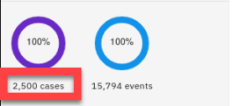

### Managing Event Data

You can use the above technique to generate as many events as you need incrementally. Let's learn how to manage the generated events.

1. Click **Datasource**

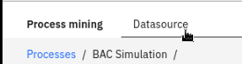

1. Click **data sources**

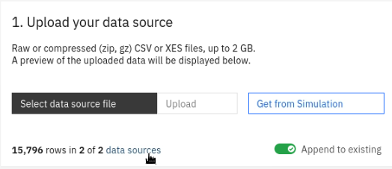

1. Click **Simulated** tab

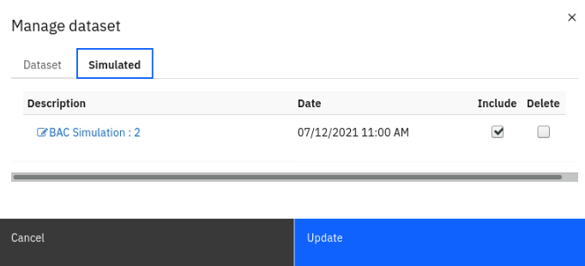

Notice the *BAC Simulation: 2* (version 20 data set. This is the data set you generated when simulating for the second time. You can either include or exclude this data set in the Process Model. For example, simply unselect the Include checkbox to get back to the original 1000 cases data set.

Also, if you like, you can also Delete this data set permanently.

1. Click **Cancel**

## Lab Summary

In this lab, you have learned how to use IBM Process Mining to simulate BPMN processes modeled in IBM Blueworks Live. And how IBM Process Mining tool can generate event data required for most process mining tasks that do not require business data beyond the primary process data such Activity Wait Times, Teams, Users, etc.